Incoterms 2010
Incoterms 2010 – a unified rules developed by the international chamber of commerce, which should be guided by the conclusion of foreign economic transactions and the organization of international cargo. It contains the only correct definitions of international trade terms, especially those relating to Franco. They clearly define the key responsibilities of the parties in the implementation of contracts of sale between the subjects of law of different countries. For the first time these rules were adopted in 1936. Incoterms 2010 is the latest edition, which entered into force on January 1, 2011 and is valid until now.
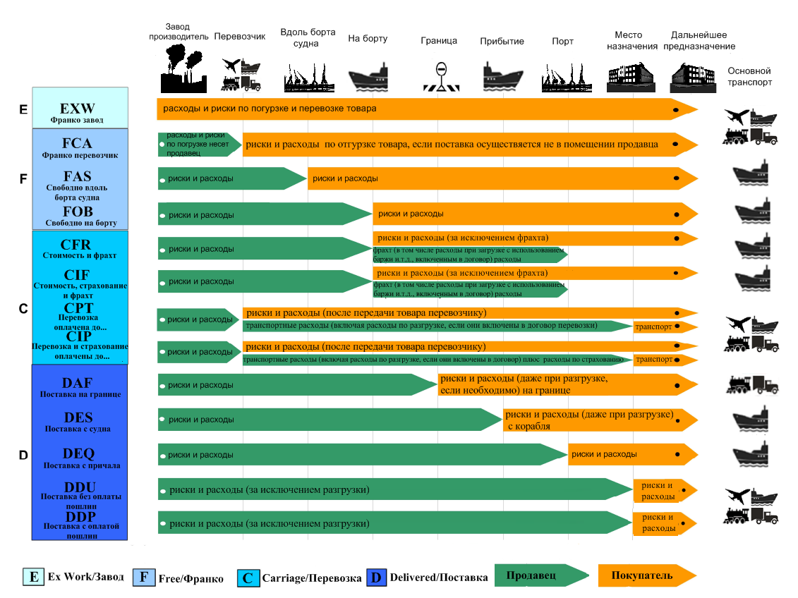
Incoterms 2010: decoding and delivery terms.
Incotrems contains the terms in are abbreviations of three letters. The first letter of the abbreviation indicates the moment of transfer of responsibility for the goods from the supplier to the buyer. According to this principle, they are divided into 4 groups:
• E — supplier is not involved in the delivery process. The seller has the minimum duties – betrays goods in own warehouse. The buyer independently takes it from the warehouse of the seller for further transportation to the destination
• F — the seller does not pay for the main delivery. Most of the transport and customs costs are borne by the buyer or its carrier with whom it has entered into an agreement. It is he who picks up the transport, carries out the loading of cargo and its delivery, and the seller only gives him the goods at the agreed point.
• C — the terms of delivery under which the seller bears the main costs.
• D — the seller is fully responsible and pays for the delivery of the goods to the buyer.
Category D in 2010 received changes in comparison with Incoterms 2000. Introduced two new concepts – DAT, which replaced the term DEQ, prescribes the terms of delivery to the terminal, and unlike the previous definition, can be used in multimodal transportation. The second term – DAP, introduced instead of three terms – DAF, DES, DDU, and prescribes the rules of delivery to the point agreed in advance with the buyer.
The organization and carrying out of delivery of the goods by any mode of transport is regulated by the eleven Incoterms 2010. For convenience, a detailed explanation of the terms of delivery is presented in the table below.

Category E | EXW | any types of transport | Delivery of cargo on the terms of self-delivery. The seller has minimum duties. The buyer, purchasing the goods, completely takes the organization of its delivery - accepts the goods, packs, insures, transports on own or hired transport to the right place, pays export and import duties.
Category  F | FCA | category any means of transport | The Seller delivers the goods cleared of export duties to the sending terminal specified in the contract and transfers them to the buyer/carrier.
 | FAS | sea and inland water transport | The Seller delivers the goods to the berth of the port of loading and places it along the vessel designated by the buyer. His obligations come to an end. Loading and transshipment at the intermediate port is paid by the buyer.
 | FOB | sea and inland water transportation | Almost identical to the terms of delivery of the goods under the FAS regime. The only difference is that the seller does not just bring the products to the ship, but also pays for its loading. In this seller's responsibilities end responsibility for the goods passes to the buyer.
Category C | CFR | marine and internal water transport | The delivery of the goods shall be the seller immediately on Board the vessel. At the same time he pays all the costs and freight for the delivery of goods to the destination, and also makes customs clearance.
 | CIF | sea and inland water transportation | Terms of delivery similar to CFR, but additionally the seller bears the cost of cargo insurance. At the same time he has the right to choose the minimum tariff rate. The amount of insurance can be increased if it is stipulated in the contract or additional agreement.
 | CIP | all modes of transport are | Subject to delivery conditions that are virtually similar to CPT except that the seller provides cargo insurance. Traditionally, the minimum rate is chosen, but if necessary, the buyer has the right to require additional insurance. In particular, the minimum insurance is not suitable for goods that require special storage or transportation conditions. If necessary, the buyer can agree with the seller and additional insurance or pay for extended insurance.
 | CPT | any kind of transport | Implies that the seller pays for the delivery of the goods to the agreed point, including export duties
Category D | DAT | any modes of transport | The New term (introduced in Incoterms 2010) is used in the event that the selling and buying party together bear The cost of shipping. In particular, the first one pays for the delivery of goods to the arrival terminal – berth, warehouse, container yard or air cargo terminal, insurance fees and export payments. The second – assumes the costs associated with customs clearance of cargo and its further transportation to the destination.
 | DAP | any modes of transport | New term (introduced in Incoterms 2010). The seller pays for the delivery of products to the agreed place. At the same time, he must perform customs formalities for the export of goods, but is not obliged to pay import duties and register it at customs.

The action of the Incoterms 2010 in Russian
The codification of trade terms of Incoterms 2010 in Russian is a recommendation. At the conclusion of transactions with foreign partners, if both parties have chosen the document as a regulator of trade relations, its provisions are taken into account without fail. Of course, if they do not contradict the norms of Russian law.

